Humbleton & Flinton Community Led Plan – 2023 Version

What is a Community Led Plan?

“A Community Led Plan is a tried and tested approach that helps local people to explore the needs of their area, set priorities and plan actions.”

Community Led Planning has a number of important characteristics:

- It is led, driven and resourced through grass roots action.
- The people working on Community Led Plans are volunteers, usually a mix of parish councillors and local people.
- It involves extensive community participation and engagement using techniques such as questionnaires, meetings, discussions and events.
- It results in a credible Action Plan based on in-depth consultation.

The Action Plan will set out how local problems and issues may be tackled. These will be a mix of activities which the community can undertake alone, coupled with actions which will need addressing in partnership with local authorities and/or other agencies.

The aim of a Community Led Plan is to give every resident the opportunity to participate in, and contribute to, improving the social, economic, environmental and cultural well-being of their local area. It relies on people coming together locally, researching local needs and priorities and agreeing a range of different actions which help to improve their neighbourhood.

Approximately 4,000 communities across England have already been involved in developing Community Led Plans since the late 1970s. These have allowed communities to take responsibility for making things happen locally, rather than waiting on others to do it for them.

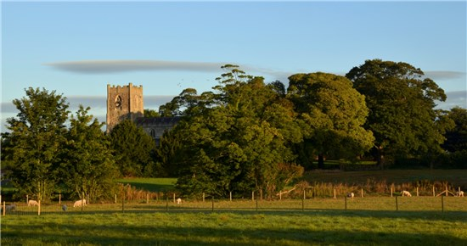
St Peter’s Church across village fields

Contents:

- About The Parish
- Our History
- The Consultation Process
- The 2019 Update Process
- The 2023 Update Process
- Report Conclusions
- Survey Results
- Action Plan

“Community-Led Planning (also known as Parish Planning) is a tried and tested process already completed by over 4000 parishes and communities nationwide. In our region this has given a voice to over 200 communities, who have used their plans to encourage community spirit and action and also help with funding bids.” Rural Action Yorkshire

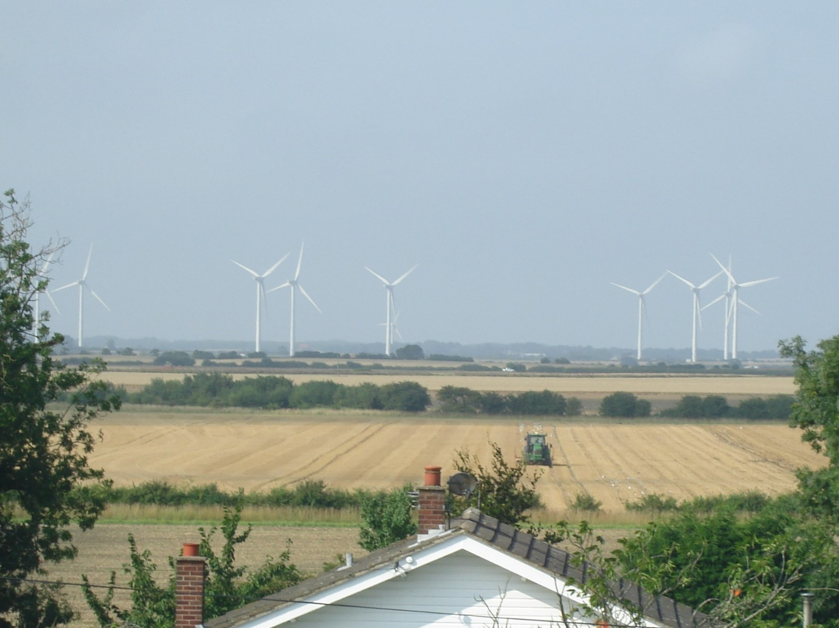
Green in every sense

ABOUT THE PARISH

Ours is a small country parish situated in the heart of Holderness, which is the part of Yorkshire stretching between Hull and Bridlington southwards to the river Humber. The village is approximately 12 miles south of Hornsea and 10 miles east of Hull.

The main road through the parish is the B1238 which runs through Flinton and connects Sproatley to the west, with Aldbrough to the east. Several smaller un-numbered roads criss-cross our area and link us to small neighbouring villages. The only public transport available are the bus services that run relatively infrequently to and from Hull and Hornsea. The Holderness Loop cycle route (a National Byway) runs through Humbleton but off-road walking opportunities are limited as our parish is one of the few parishes without any public footpaths or bridlepaths in the East Riding of Yorkshire.

The predominant industry is agriculture. This is mainly arable with several large farms owning hundreds of acres each and generating some of the local employment. There are also several smaller companies in the area ranging from a large garage to ‘home office’ type companies employing one or two people. As is normal in our type of community though, the majority of residents commute to their workplace outside of the village. Due to the flat landscape, much of the skyline in our area has become dominated in recent times by renewable energy sites, consisting of multiple wind turbines and a new biomass power plant.

There are very few facilities in the parish other than the church (and the phone boxes that now or will house defibrillators). We no longer have a school (although we still have the old school building) or public house and there is no shop or post office although all of these are available in neighbouring villages. There is however a cricket pitch / playing field with a multi-use games area owned by a local charity and used by the public and the local Cricket Club.

In the 2021 census, there were 210 people living in the parish with 126 of those of working age (16-64). Approx 33 were aged 0-15 with 35 people aged over 65.
The total area of the parish is 1,164.7 hectares. Comparing the population with the data from the 2011 Census it is clear that the population has aged slightly (+10 over 65).
The predominant industry
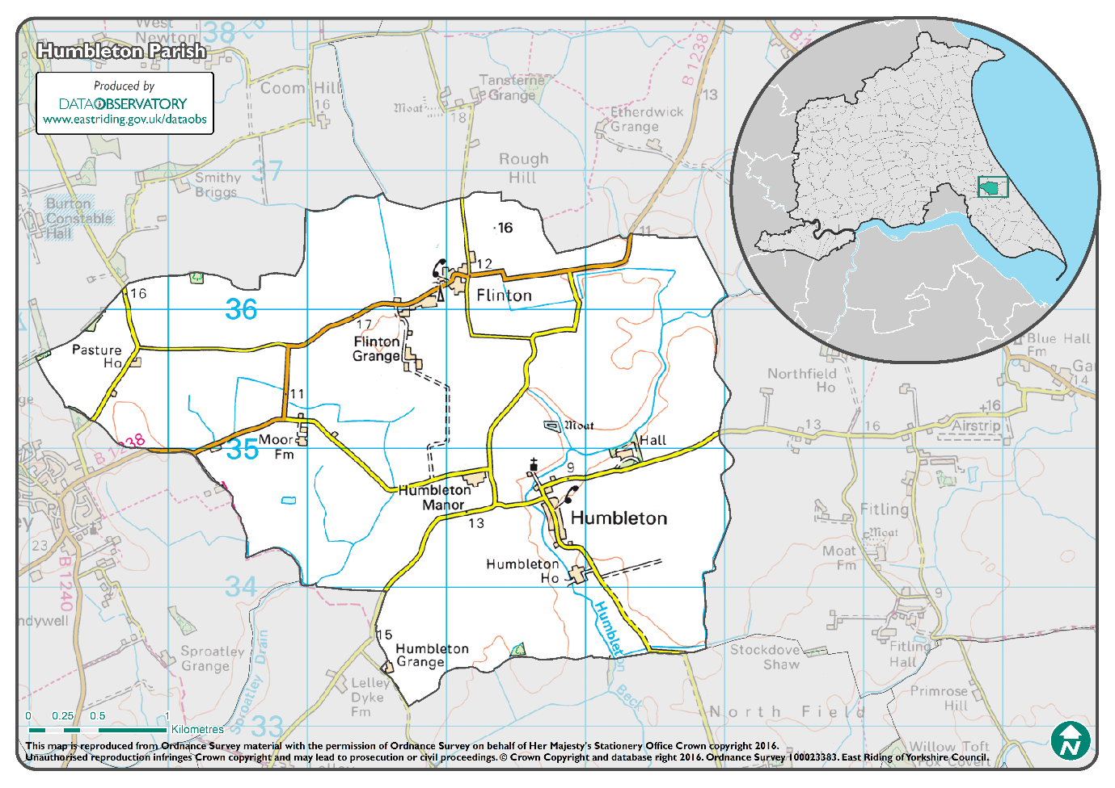

Our History
There has been some form of settlement in Humbleton and Flinton for over 900 years and both were mentioned in the Domesday Book in 1096.

Humbleton

The village is surrounded by rich agricultural land and there are five farms all bearing the village name - Humbleton Manor, Humbleton Hall, Humbleton House, Humbleton Moor and Humbleton Grange.

In 1823 inhabitants in the village numbered 136 and occupations included three farmers, a shoemaker, a tailor, a carpenter and a blacksmith. A carrier operated between the village and Hull on Tuesdays and Fridays. There was a public school for poor parish children, the school teacher receiving a salary of 21 shillings. The parish is the birthplace of Admiral John Storr (1709-83).

The village school was known as the Heron’s Endowed School and belongs to the Heron Educational Foundation. The building dates back to the early 1850s and, although it was partly rebuilt in 1905, it still resembles the original design. Children travelled from the surrounding villages of Elstronwick, Lelley, Fitling, Flinton and Danthorpe until it was closed in 1960. Since then the building had been used as a village hall for the local community although it has now been converted into housing.

St Peter’s church was rebuilt in the 13th century and further modifications and restoration were carried out in the 15th century. The oak pews and present pulpit were installed at the turn of this century and hot-water heating was installed in 1899 at a cost of £75. The 65 ft tower is said to be the best-proportioned tower in Holderness. There are three bells in the belfry dating from 1594 but ringing of the bells ceased in 1935 as the bell rollers became in need of extensive repairs. The clock was installed in 1920 with money raised by the parishioners with the intention of creating a long-lasting memorial to those who served and gave their lives in the First World War. Unfortunately the parish clock is in need of repair and has not worked for several years. The well-equipped organ has two manuals and was built by T. Hopkins and Sons of York who installed it in 1910; the air was pumped by hand until 1950 when an electric blower was installed. Humbleton did have a Methodist Chapel but this was converted to a private residence many years ago.

The development plan created by East Riding of Yorkshire Council has clearly defined the opportunities in the village for any residential building and this is limited to the current available green areas within the village itself. There are no opportunities in Flinton to develop any more housing according to the development plan.

The Green in front of Townend Villas has limited parking and all the utilities serving the village are retained there, affecting any opportunity to increase parking facilities for the growing number of vehicles in the village.

Approximately half the village are on mains sewerage with the rest of the residents on private septic tanks.

The villages are surrounded by gas lines from Middlesbrough feeding into Saltend, however there is no main gas in the villages, meaning that residents are restricted to other sources of utilities including electricity, LPG and oil.

Speed limits within the village are mainly restricted to 30 mph, however the village has lots of large farm traffic and children playing in the village around cars parked on the roadside.

Flinton

Much of the land in the village was owned by Thornton Abbey (N Lincolnshire) from around 1150 until the Dissolution when it passed to the Crown. The lords of the manor were the Grimston family from the mid 14th to mid 17th Century and then the associated land passed to the Hildyard family until 1848 when it was sold to the Constable family (who had held some land in Flinton since the 13th Century) retaining the land as tenant farms to the Burton Constable estate until the 1960s.

At 65 feet, Pit Hills in Flinton is one of the highest pieces of land in Holderness and was used for stone extraction until Victorian times.

At various stages in its history, Flinton had a Manor House (with an associated chapel), a windmill, a Wesleyan chapel, a poor house and several alehouses. It is now without all of these and forms part of the parish of Humbleton and comprises a number of farms dating from the 18th Century and smaller dwellings from the earlier 20th.

Flinton by its nature is a corridor based on the B1238 road through the village and does not have any central point, such as a village green, for the residents to congregate except for the recently adopted phone box.

There is no public sewerage in Flinton and, like Humbleton, mains gas is not available. The speed limit through the village is 30 mph, but the straightness of the B1238 for half the length of the village tends to encourage transitory traffic to go faster than this. Fortunately, residents do not need to park on the road and children do not play on or near it due to the amount of traffic.

The Consultation Process
The first meeting of the volunteers who were interested in having a Community-led Plan took place in March 2016, they became the Steering Committee. At the meeting, it was agreed that a Plan would be useful as a means of capturing the aspirations and concerns of the villagers and thereby assisting in getting our voice heard when decisions were being made that would affect our community. Examples cited included planning permission, transport reviews, infrastructure enhancements and funding applications. It was decided that the next step to creating the Plan would be to engage with as many in the community as possible through a questionnaire and by seeking views at community events. The intention was that the entire process up to circulation of the final plan would take approximately 18 months.
Engagement with the community started at the ‘Family Fun Day’ on 17 July 2016 where local residents were asked to identify issues (positive and negative) that mattered to them and to rate them Red (a concern or cease), Amber (needing to be done better) or Green (maintained or enhanced). These initial findings were then taken to the village Halloween Party where attendees added new issues and confirmed the validity of the earlier ones. The resultant data was then grouped into themes by the Steering Committee members to simplify analysis at subsequent meetings.
In addition to the ‘in person’ consultations, the Steering Committee drew up a questionnaire that was delivered to every house in the two villages by committee members in August 2016. Questions included requests for information about age, gender and employment status of residents as well as space for lists of issues and concerns to supplement the ones raised during the village events. The number of responses was in line with statistical norms for this type of consultation – providing indicative information from sections of the community rather than truly authoritative responses from all groups. That said, the information was very useful, enabled everyone who wanted to participate to do so and greatly helped in the assembly of the subsequent plan.

The 2019 Update Process
It was agreed as part of the original 2018 Plan that we would have an annual review process in order to keep our Community-led Plan up to date and relevant to the residents. As a result, a Steering Committee meeting was held in June 2019 to identify key changes, review the Action Plan items and recommend changes to reflect progress, or lack thereof, over the previous 12 months. This then led to the production of a draft Report and Action Plan.
The existence of the draft was then promulgated by a variety of means to ensure the widest possible awareness and maximum opportunity for comments from all residents who wished to do so. Following a suitable period for responses to be made, those received were considered by the committee for inclusion and a final draft Report and Action Plan were produced.
This final draft was then made available for one month prior to it being released as the official Community-led Plan for Humbleton & Flinton for 2019. It was intended to follow a similar process in 2020.

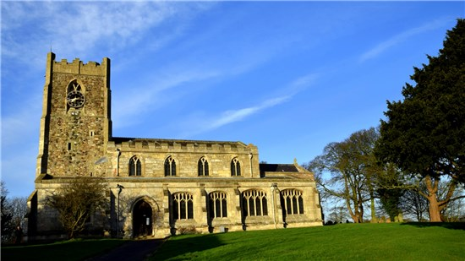
St Peter’s Church

The 2023 Update Process
The 2019 aim of updating every year was not achieved due to the COVID pandemic. Instead, once the worst of this was over, it was decided to run a short update process in 2022-3 to keep the Community Plan relevant and up-to-date with an intent to conduct a more thorough consultation and publish an update in 2024.
As a result, the 2022-3 update was completed from October to May and took the form of an update by the Steering Committee, a meeting of the Parish Council and a short consultation period using social media and then the publication of this Report in May 2023.
One positive outcome from this process, is that we have noticed how much has been achieved since the start of the process. These changes are reflected beneath the original paragraphs below.

Report Conclusions

In 2022, the Steering Committee continues to believe that this updated report has accurately recorded the opinions of those who have been prepared to express them, either during the original process or through informal and formal consultation since then. It continues to be a fact that not everyone replied to the questionnaire, not all of those who did reply answered all the questions and not everyone has expressed an opinion since the Report was published. Clearly, we cannot be certain that this report is fully representative of the views of the whole community, but it seems reasonable to conclude that it is likely that those who mind most about the environment in which they live will have given us their comments.

Four overarching conclusions about the village population can be derived from the Consultation Process:

- We have a mix of Ages, Activity and Home Ownership
  - The needs of young, middle-aged and old will need to be taken into account
- There is no reported Unemployment
  - Generating new employment opportunities is likely to be less important to residents than maintaining what we have and enabling access to employment locations
- Most residents moved into the villages from elsewhere in the East Riding
  - They were very familiar with the area and its positives and negatives before they moved here
- Many people here are long-term (greater than 10 years) residents
  - People have a long-term stake in the future of our community

Survey Results

The ‘headline issues’ from the Consultation Process were:

- Speeding Traffic – This originally came mostly (but not exclusively) from Flinton residents relating to the B1238 but is also being raised increasingly by Humbleton residents as well. Traffic levels on our roads have remained broadly unchanged in recent years, but there are enduring concerns about speeding through the villages. At residents’ request the Council (ERYC) conducted a survey on the B1238 in early 2017 to assess the level of speeding, but findings were inconclusive (partly due to the siting of the equipment). Despite our more recent but unscientific evidence-gathering, the Council’s view remains that, although there is conclusive evidence of speeding, it is not of a sufficient severity to warrant provision of a permanent facility or regular law-enforcement presence. We will need to continue to monitor this and have re-approached Humberside Police through our diligent local PCSO as it has not improved. One suggestion is that residents could be trained to use hand-held speed devices for use in both villages when police personnel are not available. In Humbleton, on-road parking was also seen as a factor for traffic as it reduces the available road width and may obscure drivers’ views of children on the roadside
  - 2023 Update. As part of a Humberside Police initiative, in November 2019 a number of villagers formed a Community Speed Watch (CSW) in both Humbleton and Flinton. Since then, the Flinton group has remained active and can often be seen at the roadside, collecting information on speeding vehicles to be actioned by the Police. The Humbleton group never had sufficient volunteers and have ceased operations – we can therefore safely conclude that speeding is no longer of sufficient concern to the residents of Humbleton, but continues to be an issue for Flinton.
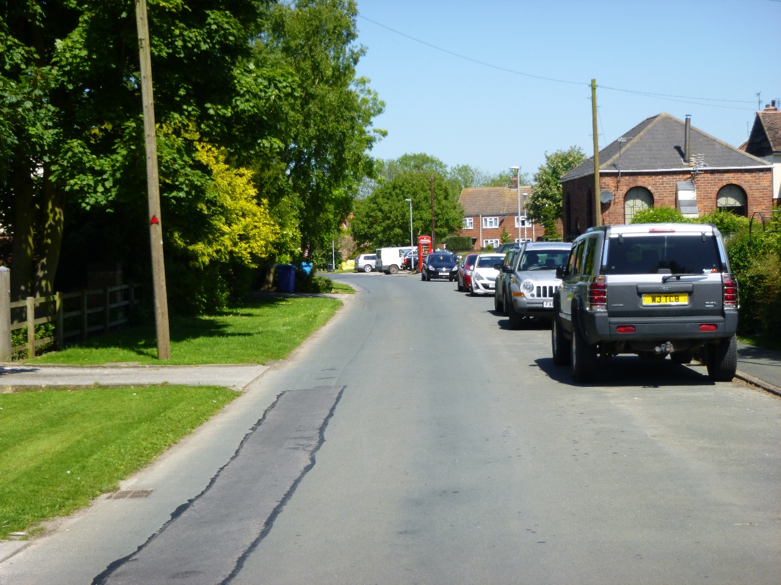
Humbleton Streetside
- Community Building – There continues to be widespread support for the provision of a Community building for functions, events and meetings in the village. There have also been suggestions that such a building could house key facilities such as a shop, tearoom, cash point and/or post office. Three potential options were identified:
  - Old School Building. The most obvious candidate for this was originally identified as the Old Village School (owned by the Heron Educational Foundation – a charity whose trustees are mainly local residents) but this is now planned to be converted into housing and can no longer be considered a viable option as a Community Building.
  - Humbleton church (St Peter’s). The original Plan identified that the village church could serve as an alternative. It has continued to be used for a number of village events (secular and religious) and proved to be very suitable as it has been well-maintained throughout its long history. If the church is to continue to fill the role of Community building for all events however, some work will need to be done to provide toilets and kitchen facilities. Funding would need to be sought for this from numerous sources, as well as approval from the Diocese of York for any proposed changes. From recent conversations however, it is not clear whether the church authorities plan to proceed with this plan, continue with current church usage or even retain the church at all.
    - 2023 Update. The church has now been equipped with toilet facilities and is still being used for very occasional services and secular events – but its future remains uncertain.
  - Cricket Pavilion. In mid-2019 the Heron Education Foundation’s trustees submitted planning permission to renovate and upgrade their current cricket pavilion into a combined pavilion and community facility. This decision marks the end of a long period of consultation and applications for grants/sponsorship, but residents will still have a final chance to make their views known on this project as part of the planning process through ERYC. If the planning application is successful, the new building should meet the community’s requirement for a community building by the end of 2020.
    - 2023 Update. The planning application was successful but funding is still required before the building can be started. Meetings have taken place between Heron Trustees and Humbleton Recreation Club to put together a funding plan but sources and timing still need to be confirmed.

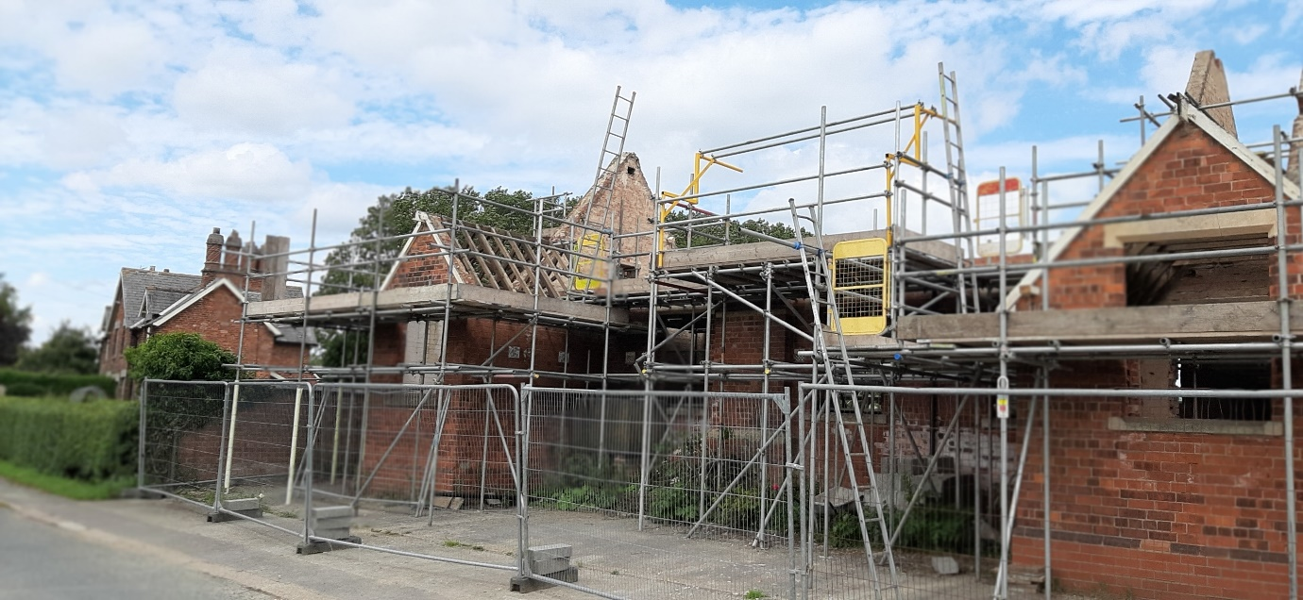

The start of the Old School Building conversion
- Industrialisation – This related to a general desire to maintain the quiet and agricultural ‘feel’ of our villages and a specific concern about issues around the new biomass power plant on the parish border, which is still not yet ‘operational’. When raising the issue of the new biomass power plant, most respondents were more concerned about the planned rise in heavy goods traffic bringing fuel (woodchip) to the plant along the parish’s roads than the other environmental aspects such as pollution and noise which seemed to be covered within the planning permission constraints. That said, monitoring all aspects of this new development and any future ones continues to be felt by many to be important. On maintaining the ‘feel’ of the village, there was a general recognition that some level of development was inevitable and probably essential if the village was not to decline over time due to a lack of new (and younger) residents, but that any development should take into account the rural nature of the area and the limited facilities and infrastructure (the parish has no doctors’ surgery, school, shop, post office or public house and very limited on-road parking).
  - 2023 Update. The biomass plant and a recent application to extend it continues to be a concern – especially regarding traffic levels. 5 years after being built, the biomass plant is still not ‘operational’

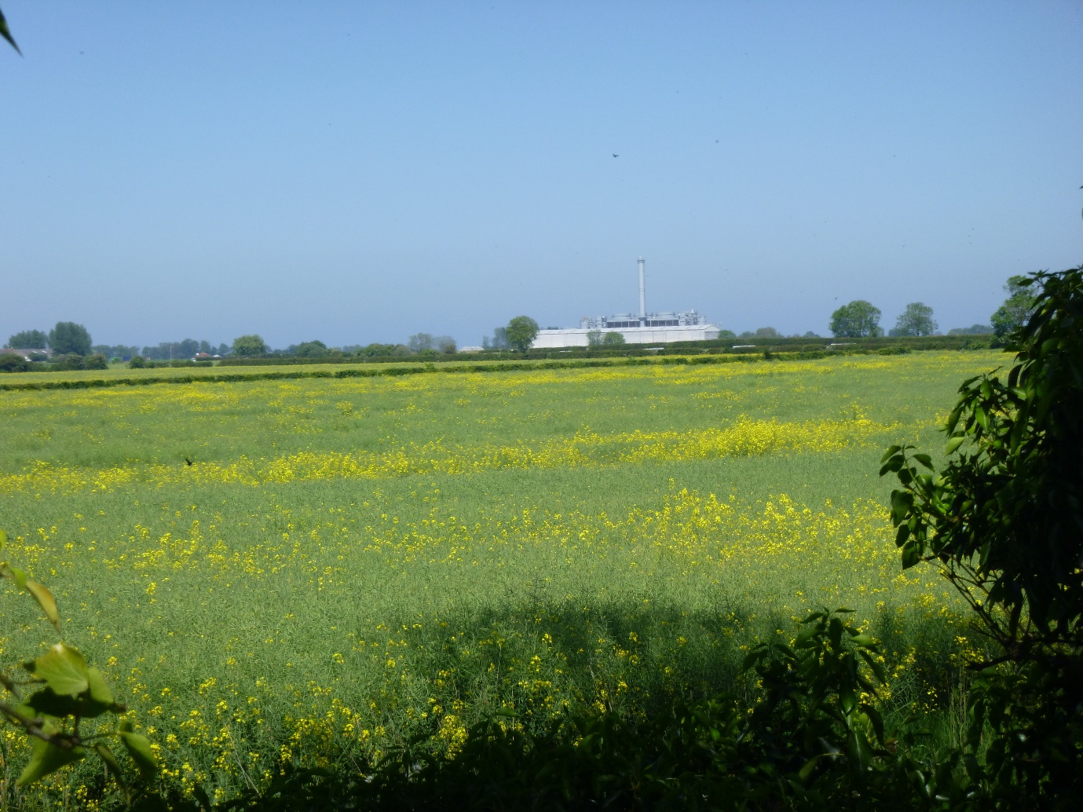
The Biomass Power Plant
- Planning Applications – It was felt that any new housing permitted should aim to balance ‘affordable’ dwellings with the more expensive developments given relatively low income levels for younger residents – a mix of rental and owner-occupier properties was generally felt to be most appropriate for the future. Again, on-road parking is a concern as was the lack of public transport and facilities. Aside from housing applications, there was an acceptance that the village could not attempt to ‘stand still’ and that some additional non-housing applications would be reasonable, although many felt that there are now more than enough wind turbines in our area which can be seen in almost every direction.
  - 2023 Update. The new properties being built by the Heron Educational Foundation are all classed as ‘affordable’ (ie 80% of market rate). This was felt to be in-keeping with the residents’ views expressed above and the application received overwhelming support.
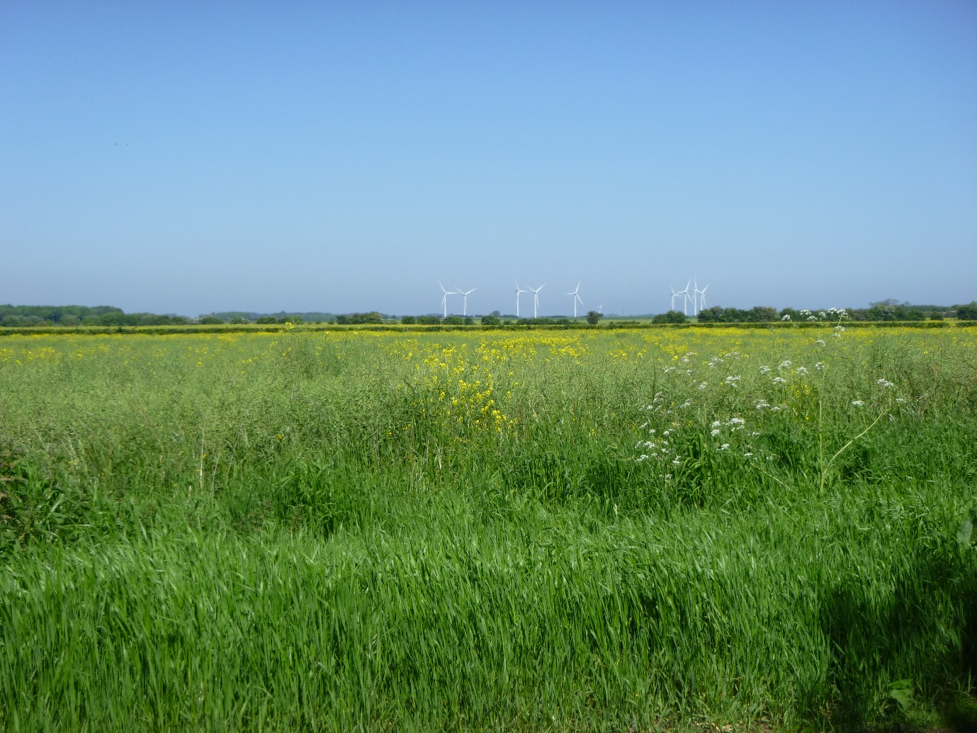
Wind Turbines across the fields
- Street Scene and General Environs – Respondents were generally very happy with the overall appearance of the village and were keen to maintain the rural atmosphere and enjoy the peace and quiet for which they moved here. Several people suggested placing seats on Humbleton Green to allow an opportunity to rest whilst enjoying the view – perhaps with the addition of planting boxes to enhance the scene. The provision of dog waste bins was also suggested as a way of ensuring that the environment of the village was maintained for the use of all residents – this issue has been raised several times in the last year. In the past, a Village Walk had compensated for the unusual lack of parish public footpaths but this facility had been withdrawn several years ago by the land owners. It was suggested that an approach be made to ascertain whether this, or a suitable alternative, could be made available to responsible walkers. It was felt possible that ‘Right to Roam’ legislation might enable this request to gain traction.
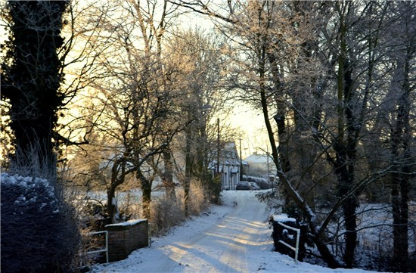
Winter view into Humbleton from the church
- Play Facilities – given the number of children in the parish it was felt that play facilities (swings, climbing frame etc) could be provided, perhaps on the conveniently sited Humbleton playing field (owned by Heron Educational Foundation) where a similar amenity had existed in the past. This is addressed within the planning application for the new pavilion and will be very welcome if approved later this year
  - 2023 Update. The application was approved and does contain a play park attached to the Community Centre. Funding is however still awaited.
- General Safety and Security – our rural location has meant that levels of all types of crime are lower than in the towns and cities but that does not mean that crime does not happen or that it is not a concern to residents. Whilst Humberside Police continue to assure us that they are ‘committed to the policing of Wildlife and Rural Crime’ the numbers of police personnel in our area means that response times can be long and crime prevention is likely to be more effective than subsequent detection activities. Suggestions to address concerns included rejuvenating the Neighbourhood Watch scheme (currently run as part of the Parish Council rather than a standalone group) and further improving street lighting provision within village centres.
  - 2023 Update. This is an area of increasing concern. There have been numerous recent examples of minor vandalism and anti-social behaviour in Humbleton.
- Broadband – the Government’s plan to ‘provide superfast broadband coverage to 95% by December 2017’ has delivered improvements to both villages. In early 2018 the upgraded cabinet was installed in Humbleton but there are still some issues with achieving and maintaining truly ‘superfast’ speeds. Flinton is subject to a different programme of works, which has recently delivered ‘fibre to the premises’ and should give much faster speeds but it is too early to tell at publication date whether this is really the case. Broadband access was one of the highest priorities in the original Plan but is now a little lower while we continue to monitor performance levels. Given the criticality of this issue for modern living there is no doubt that it will become a high priority if performance does not match promised levels.
  - 2023 Update. As hoped, the Flinton ‘fibre to the premises’ connection has delivered extremely fast connections and good reliability. Humbleton residents are generally content with the speeds and reliability of their broadband, but the restriction caused by using old-fashioned copper wires from the cabinet to the property means that this facility cannot be truly described as ‘modern’. The new Heron properties are however directly connected to fibre (which will exceed Flinton speeds), so it is hoped that this represents the future for the village – although no date has been given for the wider upgrade.
- Road Maintenance – the reliance on road usage for all aspects of life in our parish means that residents are especially vulnerable to the impact of poorly maintained roads. The damage caused by a pothole to the family car will have an effect on travel to work, trips to the shops and the daily school run whilst a road closure will result in a lengthy, time-consuming diversion. Fortunately our relationship with ERYC is good and they continue to be very responsive to reports of pot holes, which have usually been repaired promptly.
- Local Environment – the key positive factors that residents listed during the Consultation were centred around their enjoyment of the environment, peace and quiet and rural life. It is no surprise therefore that issues around fly-tipping, roadside litter, dog fouling and footpaths were raised by several households. While fly-tipping is unsightly and spoils the enjoyment of the countryside for some, for farmers it can cost many thousands of pounds per year to clean up the mess. Actions suggested to assist with this specific problem ranged from increased Council activities (patrols, collections, CCTV) to more vigilance by residents to report suspicious activities. On litter more generally, regular village clean-ups by dedicated, properly equipped residents have provided a solution in Humbleton and are being considered for Flinton.
  - 2023 Update. Humbleton village clean-ups continue to be suitably supported by a few keen volunteers. There has only been very limited support for the clean-ups arranged in Flinton.
- Public Transport – the numbers regularly using public transport amongst our respondents was small, but for those individuals with limited/no access to their own vehicle the lack of local facilities in the parish mean that a bus service is a vital amenity. Sadly, the services have worsened since the original Report. Flinton now has only one (two on Tuesdays, Thursdays and Saturdays) early morning bus trip to Hull (with a change in Bilton), with no return services unless you are prepared to walk the 20 mins from Humbleton Moor bus stop. Except those from that bus stop (35 mins walk) for Humbleton there is only one bus in the morning to Hull and two back (late morning and mid-afternoon), but these all take over an hour and the service to Hull runs only on Mondays, Wednesdays and Fridays; all services also require a change (this time in Wyton or Withernsea). Suggested solutions include local car- and taxi-share schemes and increased use of community solutions such as the Holderness Area Rural Transport (HART).
  - 2023 Update. There are no longer any buses to/from Flinton or Humbleton. The closest bus stops are in Sproatley and Aldbrough – both over an hour’s walk away.

Community Transport Option

Updated Action Plan
Issue | Action | How to tackle it | Lead Organisations  & Partners | Benefit | Priority | Timescale
Speeding Traffic - Flinton | Monitor & Report any worsening of situation | Support Community Speed Watch volunteers | Parish Council | Accurate monitoring/control of problem at limited cost to Council | -
Community Building - Church | Retain the church as a usable building in the village | Understand the strategy from the Diocese / local church wardens / vicar | Diocese of York – Parochial Church Council | Enhance utility of current building; retain key village facility and focal point | -
Community Building – Heron | Support fund-raising process | Engage with ongoing project | Heron Educational Foundation | A new purpose-built sports and community building | 1
Biomass Power Plant | Monitor traffic and pollution levels (including noise) | Compare levels to those on planning permission | Parish Council in conjunction with ERYC | Ensure minimal impact | -
Planning Applications | Scrutinise new applications | Ensure that new buildings are in keeping with and sensitive to needs of village | Parish Council | Ensure appropriate growth and development | -
Street Scene | Addition of bench, dog mess bins & planters | Seek funding and volunteers (for planters) | Parish Council | Enhance current amenity | -
Village Walk | Increase off-road walking opportunities | Approach local landowners and Council | Parish Council | Create new amenity | -
Play Facilities | Provision of communal play area | Support Heron/Rec Club funding activities | Heron Foundation, Rec Club | Safe play area for children, enhance appeal of village | 2
Security | Increase physical security measures | Seek funding, consult Police. Reinvigorate Neighborhood Watch | Parish Council, Police | Enhance security, deter crime | 3
Broadband | Ensure improvements and monitor performance | Monitor/report standard of provision | Parish Council, Residents | Enable modern levels of personal and business internet access | -
Road Maintenance | Ensure safe roads | Report problems as they develop | Parish Council, Council | Safe driving, enhance access to facilities | -
Fly-tipping | Monitor & Report | Report instances, publicise contact numbers | Parish Council | Reduce incidents, target offenders | 3
Roadside Rubbish | Remove | Organise and equip regular volunteer litter pick-ups | Parish Council | Remove and discourage litter | 3
Public Transport | Provide alternative options | Connect those in need to other individuals or HART | Parish Council / ERYC | Cost-effective alternatives | -
Community Plan | Update through 2023 | Ensure Plan stays relevant/useful | Steering Group | Community led planning | - | 2024 Update

https://www.yorkshiretravel.net/ accessed 21 Jun 19

